Time Marches On
Heber Valley Quilters
2011 Block of the Month

June--Lincoln Block

The block for June is called Lincoln. This one represents the American Civil War in our Time Marches On quilt. Many people have heard stories about Abraham Lincoln that portray his many virtues and noble characteristics, but here is a story you probably have not heard that shows yet another side of the great man.
When Abraham Lincoln was sixteen, he played a practical joke on his stepmother that became legendary. Sarah had just whitewashed the inside of the cabin, and everything sparkled – the walls, the floors, the ceiling. Feeling “please and proud as punch,” she headed off to church. The moment she was out of sight, Abraham called to a barefoot neighbor boy wading outside in a mud puddle. Picking him up and holding him feet first, Abraham walked the child up one side of the cabin, across the ceiling, and down the opposite side. When Sarah returned, she took one look at the little footprints on her fresh white surfaces, gasped, and then “laughed to burst a seam,” recalled Dennis Hanks. Once the fun was over, Abraham whitewashed the cabin again, the joke well worth the extra effort.
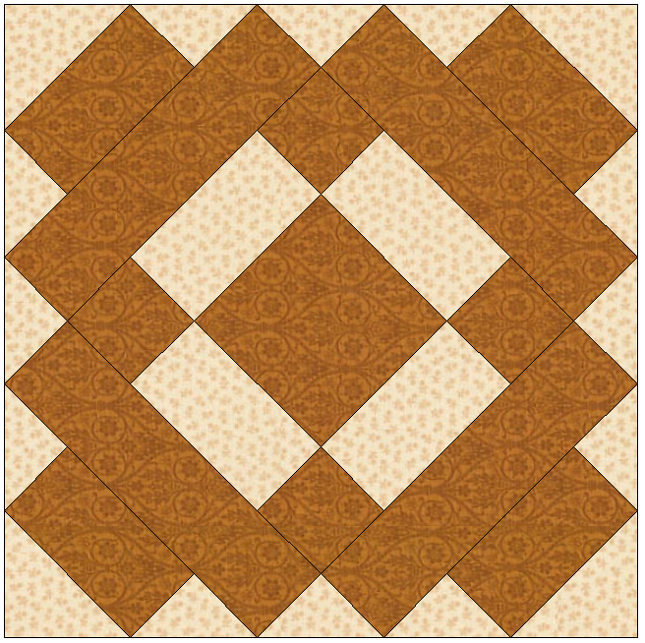
Make 1 – 12” finished (12 ½” unfinished) size block.

Cutting
Fabric A (gold)—1 – 3 7/8” square, 4 – 2 ¼” squares,
4 – 2 ¼” x 7 ¼” rectangles, 4 – 2 ¼” x 3 7/8” rectangles
Background fabric—4 – 2 ¼” x 3 7/8” rectangles,
2 – 3 ¼” squares, 3 – 3 5/8” squares

Block Construction
- Using 4 fabric A 2 ¼” squares and 2 background 2 ¼” x 3 7/8” rectangles, stitch one fabric A square to each end of background rectangles. Press toward fabric A.
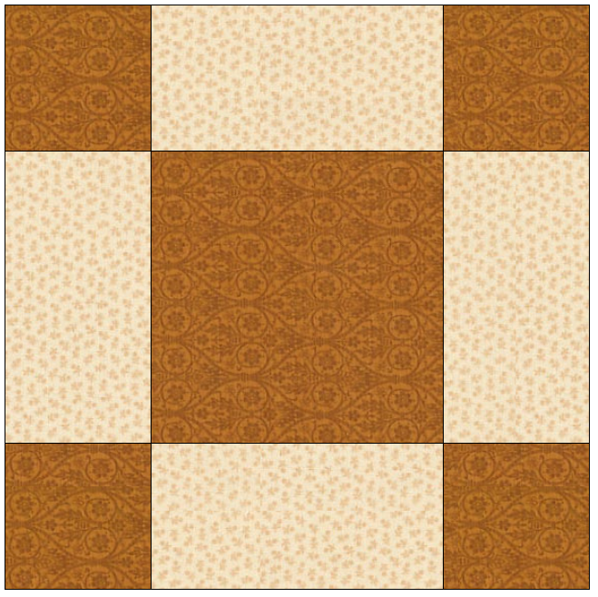
- Using 1 fabric A 3 7/8” square and 2 background 2 ¼” x 3 7/8” rectangles, stitch one rectangle to opposite sides of square. Press toward fabric A.
- Add strips created in step 1 to opposite sides of step 2 to create the center of the block. See diagram at right.
- Using 1 background 3 5/8” square cut square in half twice on both diagonals to yield 4 triangles. Referring to picture above, stitch one triangle to each end of 2 fabric A 2 ¼” x 7 ¼” rectangles. Press toward fabric A.
- Using center block from step 3 and 2 fabric A 2 ¼” x 7 ¼” rectangles, stitch one rectangle to opposite sides of center block. Press towards fabric A rectangles.
- Add strips created in step 4 to opposite sides of step 5 block. Press towards added strips.
- Using 2 background 3 5/8” squares cut squares in half twice on both diagonals to yield 8 triangles. Referring to picture above, stitch one triangle to each end of 4 fabric A 2 ¼” x 3 7/8” rectangles. Press toward fabric A.
- Stitch one strip created in step 7 to each side of center block created in step 6. Press toward fabric A
- Using 2 background 3 ¼” squares cut in half once on the diagonal to create 4 triangles. Stitch one triangle to each corner of block. Press towards fabric A rectangles added in step 8.

